Peterborough DAC

Areas for Cremated Remains

Guidance notes

DAC policy
The DAC encourages the interment of cremated remains in areas set aside for the purpose within churchyards. Special areas can be created in any churchyard, even if it has been formally closed for burials, but a Faculty to make this provision is always required.

The Chancellor’s Regulations concerning burial of cremated remains
The DAC follows the guidance notes provided by the Chancellor in the Churchyard Regulations. Full details can be obtained from the Registrar’s website www.peterboroughdiocesanregistry.co.uk or telephone 01733 262 523.

Cremated remains may be interred in:
- The existing grave of a close relative
- An area set aside by Faculty for the interment of cremated remains
- In an otherwise unused area of the churchyard, being an area not large enough (or otherwise not required) for use as a burial space.
Cremated remains shall not be interred in a plastic or other non bio-degradable container. Direct committal into the earth is, from the point of view of both symbolism and sound practical sense, the course to be preferred.

The Chancellor’s Regulations concerning commemoration of cremated remains
Commemoration may take the form of:
- Inclusion in a book of remembrance, kept in the church; this requires a faculty
- An inscription on a single communal memorial in the churchyard, where such exists
- A suitable addition to an existing memorial stone in the churchyard relating to a close relative
- A natural stone tablet bearing only the full name and dates of birth and death of the deceased. The table to be no larger than 45cm x 45cm (18” x 18”), laid flush to the ground. The stone to be of local stone or slate, not polished or with a reflective surface. Hardwood (teak or oak) may also be used
- A memorial of the sort permitted in an area set aside for the purpose by faculty. In most cases this will be a stone tablet, no larger than 45cm x 45cm (as above) but some PCCs have set aside areas with particular specifications for memorials – or prohibiting them completely.
- No tree, rose bush or other shrub may be planted by individuals in the area
- Inscriptions should simply state the full name and dates of birth and death. If precise dates are to be used they should be written out in full e.g. 29th April 1927, not 29.04.27. Lettering must not be coloured in gold.
- No plastic or artificial flowers are allowed in churchyards in the Peterborough Diocese, except Christmas and Remembrance-tide wreathes. These should be removed after a reasonable amount of time.
Please note that the existence of a memorial either in the same churchyard or elsewhere in the Diocese is not in itself a reason for the giving of permission for another like it. Precedence is not sufficient justification for a memorial which the Incumbent or Chancellor considers outside the Regulations or unsympathetic in a particular setting.

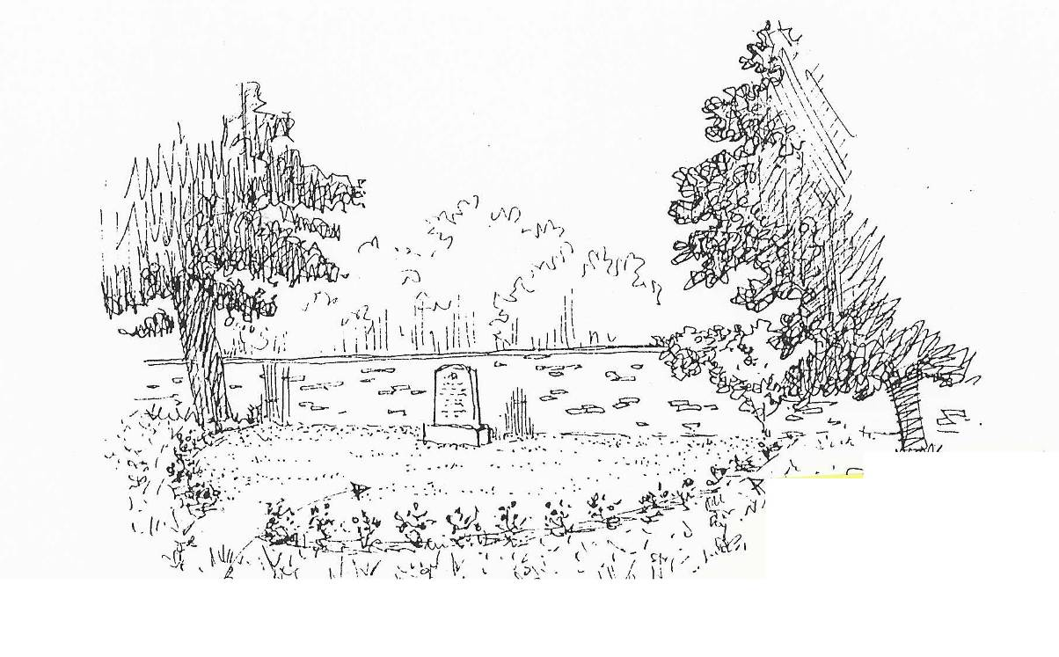

Setting aside an area for cremated remains
The DAC strongly encourages PCCs to consult with the Committee early on in the designing of an area. A site visit will usually be made by DAC members so they have a realistic idea of the setting of the church and churchyard as a whole and the PCC’s aspirations.

The following issues need to be considered:
- Cremation is becoming more popular, even in rural communities, and the area should provide space for a reasonable length of time. How large does the area need to be?
- Health and Safety issues, as well as pastoral sensitivity, mean that the plots need to be of manageable size to enable interments adjacent to existing burials without disturbing them. The DAC suggests that a minimum of 60 cm x 60cm (24” x 24”) is required.
- A plan of the area must be kept up to date. It is important that there is an accurate written record of interments for all areas, but especially those that are kept as lawns, without individual memorials on plots.
- The area, whatever the size, should be clearly defined. Will existing features e.g. walls, tombs, paths, trees, provide boundaries or are corner stones or some other way of identifying the area, required?
- Would it be appropriate to have a plaque, standing stone or wooden sign, suitably inscribed, to tell people what the area is for?
- Would a book of remembrance be a good way to commemorate the dead? This might be appropriate if the PCC decides not to allow individual memorials on plots.
- If memorials are to be allowed the PCC must ensure they satisfy the Chancellor’s Churchyard Regulations. Experience has shown that plaques 45cm x 30cm (18” x 12 “), set so the inscription runs along the longer face (landscape rather than portrait format) are large enough to remain stable in the ground without giving the area an impression of be being paved. If the area is grassed the memorial plaques should be bedded in just below the surface so it remains easy to mow the area and keep it tidy. The faculty must specify what memorials are permitted – making it clear from the outset reduces the risk of subsequent pastoral difficulties.
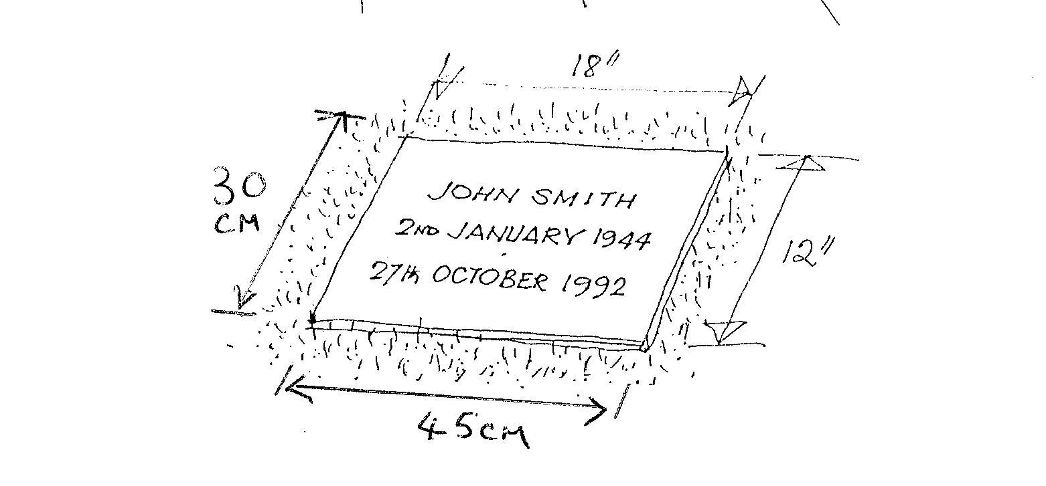
- Is the PCC planning to provide a place for flowers, so that these are not left dotted all over the area in an untidy way?
- Is there to be a seat for people visiting the area to rest on? If so, details should be included with the faculty application.
- Is the PCC planning to include any planting in the scheme: if there is to be a rose bed, or tree or bush as a focal point, full details must be provided.
- Is the proposed area safe and accessible? For instance, is there a path to it that visitors will be able to use? Is the area tucked away, such that anyone visiting the area could be vulnerable? Are the proposed boundary markers secure and obvious, so that visitors do not trip over them?

Information which will be needed for a Faculty application
- A plan of the church and churchyard showing the proposed location of the new area, its dimensions, boundary markers and any other features (e.g. paths, headstones, trees). If the area is in addition to an existing one please indicate its location also.
- Information about the size of plots and where the plan recording all interments is to be kept.
- If a stone/tablet or some other means of identifying the area is to be included, full details must be provided.
- If memorial stones are to be used, details of size, material, inscriptions, method of securing them.
- It is always a great help if photographs of the proposed area can be provided so that it is easier to envisage the location the PCC has in mind; a simple snapshot conveys lots of useful information!
- If a Book of Remembrance is to be used please provide details of the book; its colour, size and composition (especially whether it has acid-free paper), the calligrapher who will write in it and where it is to be stored.
Cont.
- If the Book of Remembrance is to be in a display case, information about the size of the case, its proposed location in the church, and type of wood used to make it.
- Catalogue illustrations or a sketch of the proposed design should be provided.

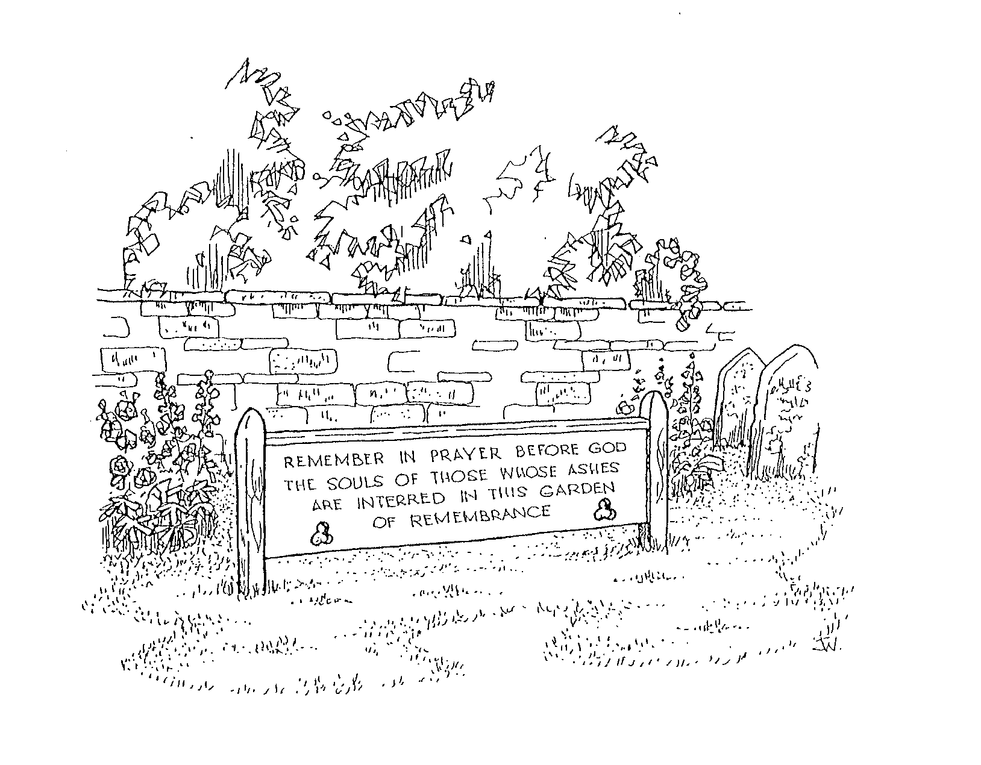
Further information
The setting aside of an area for cremated remains is a sensitive matter. PCCs are strongly advised to visit other churchyards to see how the matter has been approached – even if this only reveals what to avoid! However, each setting is different and the DAC approaches every proposal with an open mind.

The Churchyards Handbook Church House Publishing 4th edition 2001 ISBN 0 7151 7583 1 (£10.95) is a mine of information on maintaining churchyards, the legal framework, monuments, commissioning memorials and areas for cremated remains.
www.chpublishing.co.uk

The Art of Remembering ed. Frazer and Oestricher, Carcanet 1998
ISBN 1-85754-377-7 includes beautiful illustrations of a wide variety of memorials in various settings and helpful advice on commissioning one-off memorials. It can be obtained from Memorials by Artists (see below)

Memorials by Artists Commissions acts as a bridge between people looking for a good memorial and fine-lettering artists. MbA was set up as a charity after its founder struggled to find a unique and beautiful memorial for a young person who died. MbA is a mine of useful information and publishes an illustrated booklet showing 50 examples ISBN 0-9595711-2-5
www.memorialsbyartists.co.uk telephone 01728 688 934 enquiries@memorialsbyartists.co.uk
Copies of MbA leaflets are also available from the DAC office on request.

